WARM MARKET:

Hi ___________, I want to let you know that I recently came across a product based on a powerful scientific breakthrough that has created life-changing experiences and massive results in health improvement, beauty and age reversal.
With your permission, l would like to send you a quick 2 minute video - will you be able to watch it and give me your feedback?
When they say “yes”, you get the link for the 2 minute “Step1: Neumi Breakthrough” video from your Neumi App and send it to them.
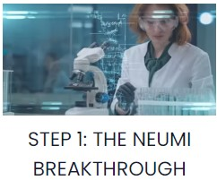
After they have watched the video, send them the following:

The Hydrastat Nanotechnology that the video talks about is a scientific breakthrough that uses Ultra Pure Water instead of lipids (fats) to wrap around nano-sized molecules creating a delivery system that is so effective, it has produced massive life-changing results for many people. Here are some examples:
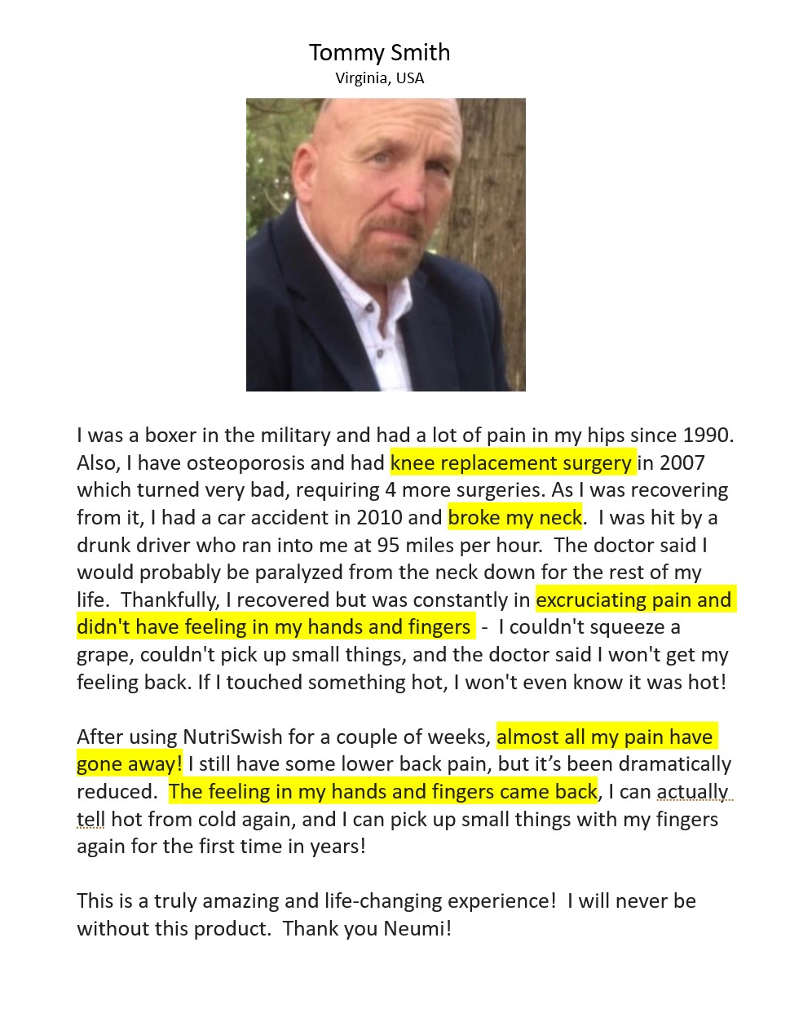
Note:
Images for both testimonials are attached to the email that’s sent to the members
Above is the experience of a member of our group in Virginia using NutriSwish - the health/oral version of our Glutathione product.

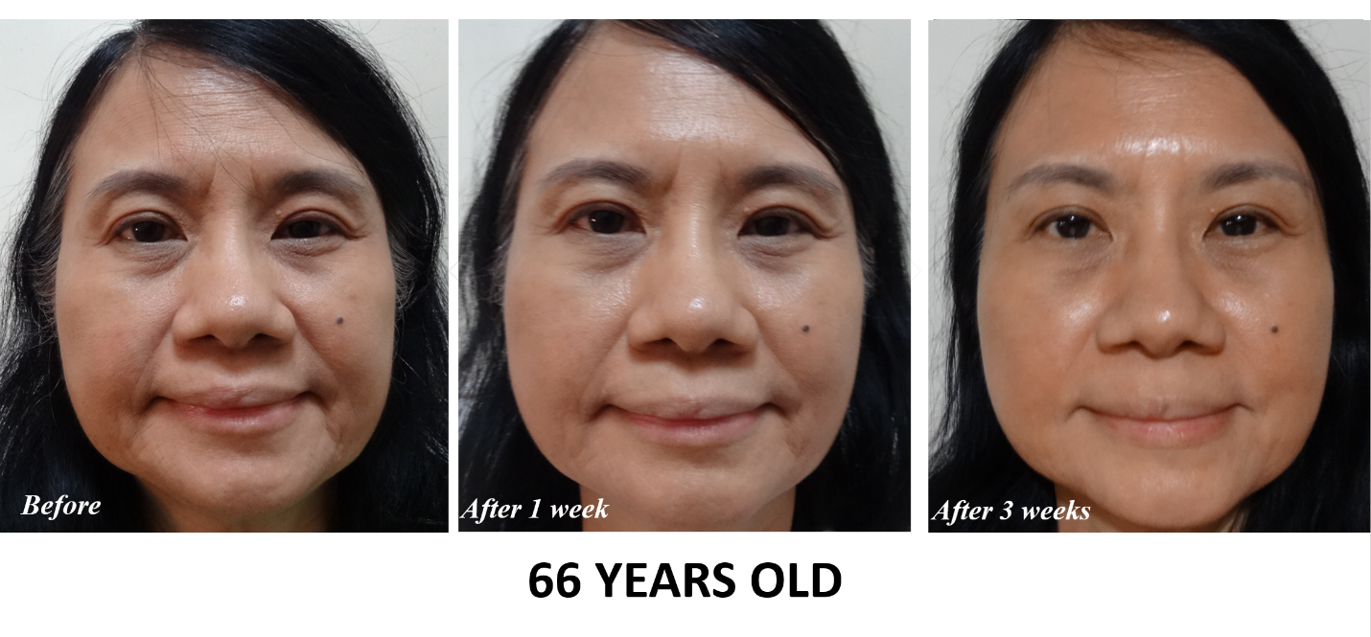
These are the Before and After pictures of my sponsor/upline, Jane Ang, based on her personal experience with NeumiSkin, the skincare/topical version of the product.

Please check out our website when you have a chance:
www.GetYounger.info

Ask them when they will be able to do that, and see whether you can get a commitment from them. Otherwise, after a day or two, follow up and ask them whether they had a chance to check out the website and watch the videos.

After this point, it’s case by case, depending on what you know about the prospect and what they need. You already have permission to send them information, so just keep “dripping” on them and find an opportunity to close them. There are a few tools you can use at this point. You can:
- Keep sending them testimonials, articles and videos that you think could interest them (both from the Neumi App and from what we send to you from time to time).
- Invite them to a Neumi zoom meeting.
- Arrange for a 3way call to answer any questions they may have.

Here are some articles, testimonials and videos that you can share:

Wayne Hanson's testimonial:
Here's the testimonial of an 80+ year old man who was near death with 9 stents in his heart, serious cardio issues, diabetes, etc.
He's recovering nicely now from using NutriSwish and is able to go outside for the first time in 6 months!
www.NearDeath.GetYounger.info

Dr. Harris' testimonial:

Powerful NutriSwish testimonial about improvements in lung capacity after COVID, vision, stamina, energy, strength, mental clarity, prostate and sleep:
www.DrHarris.GetYounger.info

Go to this page, download any testimonial you like and share them:
www.facebook.com/120yearsyoung

You can also use this google drive link to download some Before and After pictures to share:
https://drive.google.com/drive/folders/1GoOimdr5mqDNWiKZjaIBStm0LFFqzys_?usp=sharing
And here’s the link to are some pictures in Spanish:
https://drive.google.com/drive/folders/1Y-VOUKKRyjsbly3AFYTBwFe_8l11ewOz?usp=sharing

Glutathione is the Master Antioxidant of our body.
In addition to beauty, it also helps to:
1. Strengthen and balance the immune system
2. Increase energy and stamina
3. Reduce/eliminate pain and inflammation
4. Improve mental clarity and focus
5. Enhance liver function and effectively detoxify our cells
6. Increase muscle mass and improve sports performance
7. Speed up healing and recovery
8. Improve sleep quality

ARTICLES YOU CAN SHARE:

WHY GLUTATHIONE PILLS DON'T WORK (NOT ABSORBED)
Pubmed/NIH (National Institute of Health) study shows that there is no effect from taking Glutathione orally, because it is not absorbed by the body:
https://www.ncbi.nlm.nih.gov/pmc/articles/PMC3162377/

The best way to take Glutathione is through supplements using HydraStat NanoTechnology, which makes the Glutathione absorbable and readily bioavailable.

GLUTATHIONE DEFICIENCY & COVID DEATH
Groundbreaking studies show how lack of Glutathione is a key reason people die, or have serious injury, from Covid-19. Study declares ‘Deficiency of Glutathione as the Most Likely Cause of Serious Manifestations and Death in COVID-19 Patients’ (source: PubMed/NIH):
https://pubmed.ncbi.nlm.nih.gov/32463221/

Glutathione and Long Haul COVID:
https://www.ncbi.nlm.nih.gov/pmc/articles/PMC7402141

VIDEOS YOU CAN SHARE:

More Testimonials:
www.NewYou.GetYounger.info

Product Overview by our Founder, Steven Scott:
www.Overview.GetYounger.info

NeumiSkin explanation by our Founder, Steven Scott:
www.Skin.GetYounger.info

Prospecting Webinar:
www.Intro.GetYounger.info

Compensation Plan video:
www.PayPlan.GetYounger.info

COMMON QUESTIONS YOU COULD ENCOUNTER:

- How much does it cost?
The Neumi products are $50 each, and the Welcome Pack is $100 for
2 products with free membership

- Is autoship required? What is the cheapest way to get the products?
There is an incentive to get on autoship but it is not required. The cheapest way to get the products is to purchase at least 2 products for $100 so that you get the membership for free (a $35 value).

- Can you send me the compensation plan?
Let them know that:
Our comp plan is very generous with full PV which means $100 = 100 PV
This is very rare nowadays!

Send them this link to download the comp plan document:
https://share.neumi.com/social/younger/neumi/4853c061-c72e-4fcd-a958-a5f01928a155?language=en&country=US

You can also send them the compensation plan video:
www.PayPlan.GetYounger.info

Explain that the Power of Three payout is in ADDITION to the unilevel payout which makes it very lucrative, and we can show them how to earn between $1,700 and $5,000 per month consistently with just a handful of members each purchasing $100 per month.

